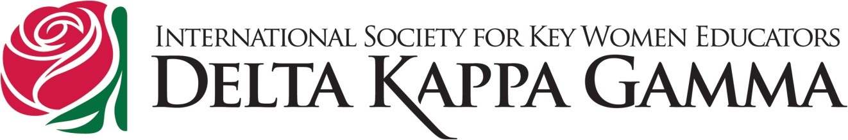

BEAR Project – 1st Year Evaluation by DKG Members

School Name __________________________________ Location ________________________

Member Name ________________________________________________________________

What did you do to help the BEAR Project at the school listed above? ____________________

How do you feel about the BEAR Project? ___________________________________________

Do you think the BEAR Project should be expanded to other schools in your area?

Have you made contacts in the community that will help buy books for this program?

Have you contacted the clinic(s) in your area who support the Oregon Pediatric Society’s Reach Out and Read Program? Is there a way that your chapter can partner with the clinic(s) to support Early Literacy? _________________________________________________________

